# **ETM595-Risk Assessment & Management – HW 2 Report**

## Gizem Yıldırım & Erdem Sirel

In the previous homework, we were asked to select 15 assets and do some calculation. In this part, we continued to work on those same assets to conduct different analysis.

**Question 1:**

In this part, the Markowitz model is adapted with different return rates: 0.01, 0.015, 0.02, and 0.025. Portfolio weights for shorting and no shorting cases are documented in the table below:

Table 1: Shorting allowed case weights

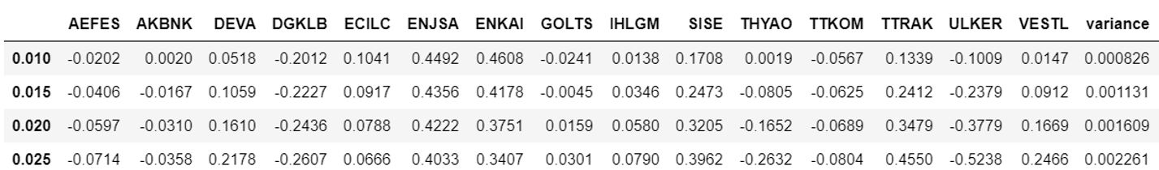

Table 2: Shorting not allowed case weights

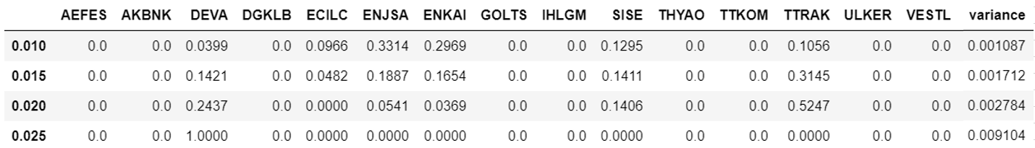

When two methods are compared, assets with negative weights are set to zero when shorting is not allowed. Also, positive weighted assets are assigned with higher values when shorting allowed than shorting is not allowed case, which is an expected result.

**Question 2:**

Applying the Markowitz model with different weights, efficient frontiers are drawn for both shorting and no shorting cases.

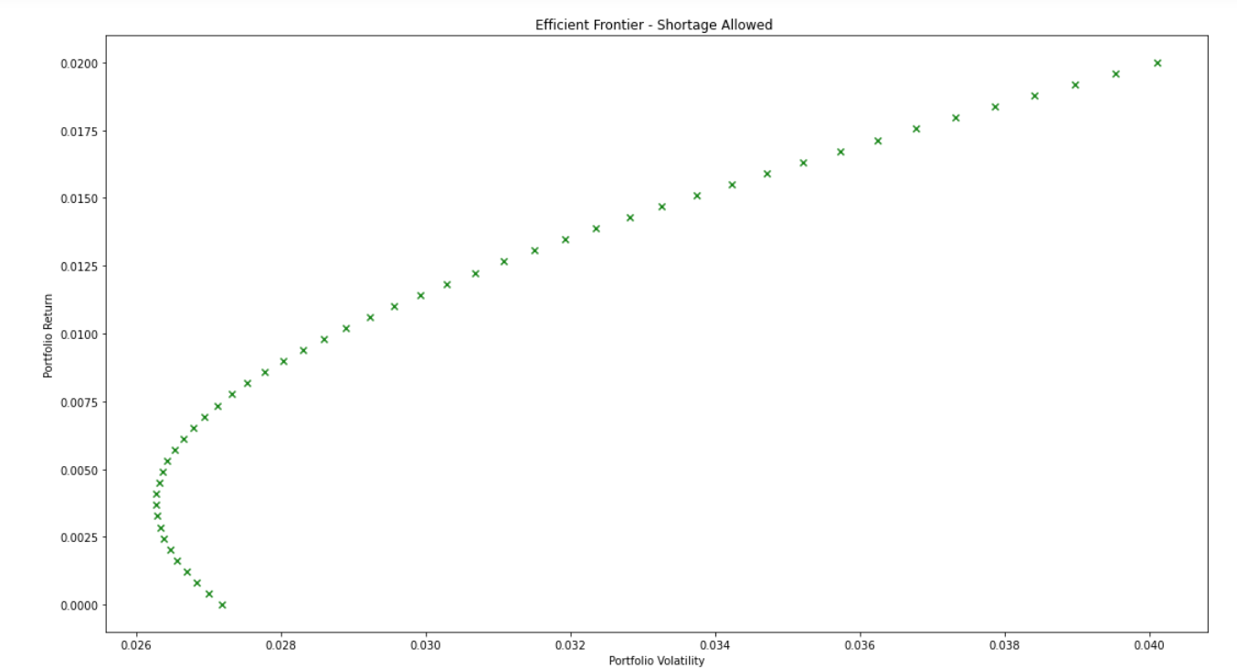

Figure 1: Efficient frontier with shorting

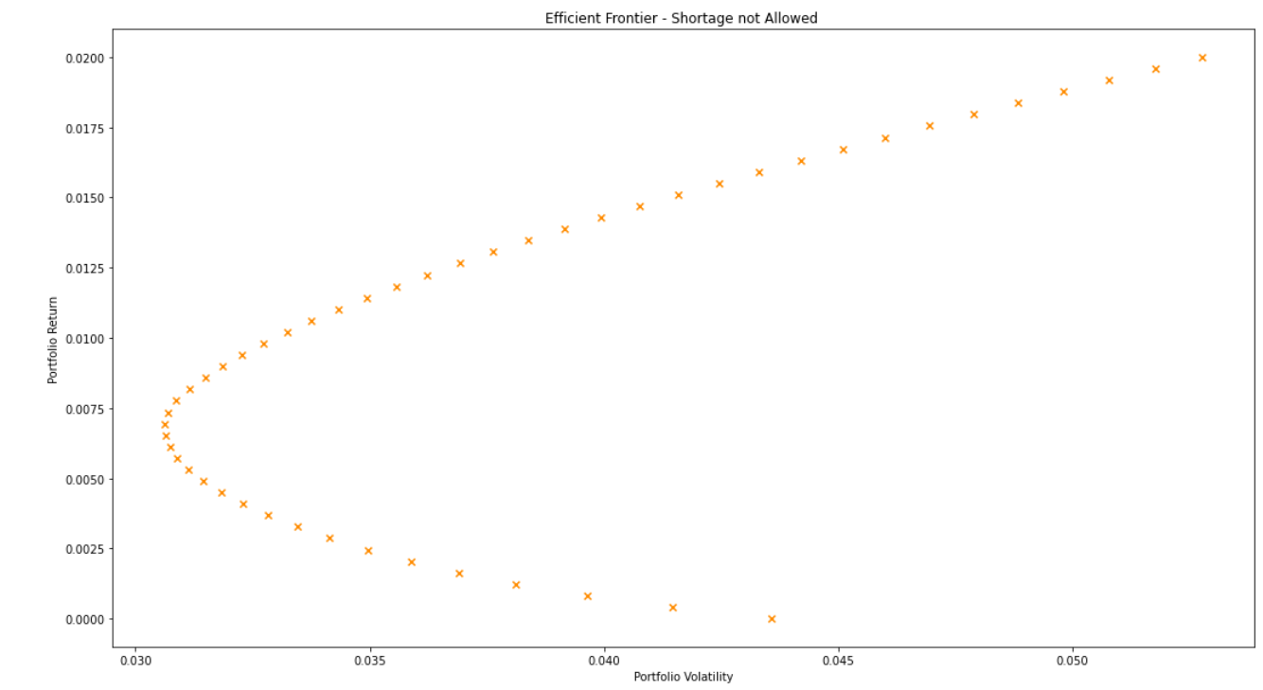

Figure 2: Efficient frontier with no shorting

**Question 3:**

In this part, we are asked to apply one fund theorem by using the central bank rate. Two different methods are conducted.

***Method 1:***

Formulations below are used to determine weights.

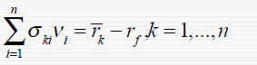

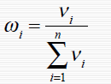

This formulation requires to solve 15 linear equations. Thus, linear algebraic calculations are performed in python.

***Method 2:***

A maximization problem is solved where the objective is maximizing the following expression.

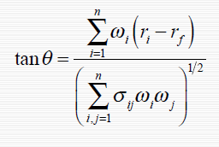

With two methods following weights are found:

Table 2: Weights calculated with two different methods

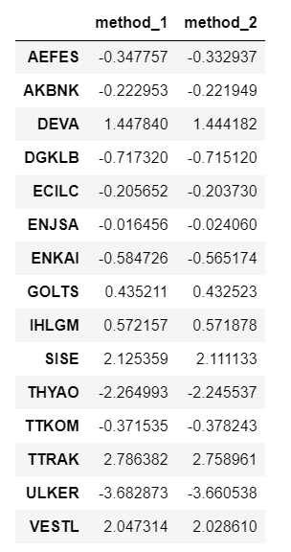

As can be seen, they are very close to each other. Portfolio mean and variance are found 0.135 and 0.06 respectively.

**Question 4:**

In this part, the probability of gaining return greater than the inflation, i.e. risk-free return is calculated as **0.705.**

$$P(return>r_{f})=P(z>\frac{r_{f}-portfolio mean}{\sqrt{portfolio variance}})$$

In the previous homework, probabilities of gaining return above the inflation were calculated as **0.604** and **0.559** for two different portfolios.

Since weights are determined with a mathematical model, having a higher probability is expected. The results support this expectation.